# **PRACTICAL FILE**

# **of**

# **“Computer Graphics Lab”**

# **PE-CS-A404AL**



# **Submitted To: Submitted By:**

Er. Shilpa Devanshu

Assistant Professor 1220199

Deptt. of Computer Science B.Tech CSE (8th sem)

**Department of Computer Science & Engineering**

**Seth Jai Parkash Mukand Lal Institute of Engineering & Technology, Radaur – 135133 (Yamuna Nagar)**

**(Affiliated to Kurukshetra University, Kurukshetra, Haryana, India)**

**INDEX**

| **S.No.** | **Program** | **Page No.** | **Date** | **Remarks** |
| --- | --- | --- | --- | --- |
| 1. | Write a program to implement the DDA line drawing algorithm. | 2 |  |  |
| 2. | Write a program to implement Bresenham’s line algorithm. | 4 |  |  |
| 3. | Write a program to implement Bresenham’s circle algorithm. | 7 |  |  |
| 4. | Write a program to move and object using 2-D transformation. | 10 |  |  |
| 5. | Write a program to implement the midpoint circle drawing algorithm. | 12 |  |  |
| 6. | Write a program to implement a line clipping algorithm. | 15 |  |  |
| 7. | Write a program to implement boundary fill algorithm. | 22 |  |  |
| 8. | Write a program to implement a polygon clipping algorithm. | 24 |  |  |
| 9. | Program To implement line clipping using Cohen-Sutherland line clipping algo. | 31 |  |  |
| 10. | Program To Scale any object. | 37 |  |  |

**PRACTICAL NO. – 1**

### **AIM:** Write a program to implement the DDA line drawing algorithm.

#include <graphics.h>

#include <iostream.h>

#include <math.h>

#include <dos.h>

void main()

{

float x, y, x1, y1, x2, y2, dx, dy, step;

int i, gd = DETECT, gm;

initgraph(&gd, &gm, "c:\\turboc3\\bgi");

cout << "Enter the value of x1 and y1 : ";

cin >> x1 >> y1;

cout << "Enter the value of x2 and y2: ";

cin >> x2 >> y2;

dx = abs(x2 - x1);

dy = abs(y2 - y1);

if (dx >= dy)

step = dx;

else

step = dy;

dx = dx / step;

dy = dy / step;

x = x1;

y = y1;

i = 1;

while (i <= step)

{

putpixel(x, y, 5);

x = x + dx;

y = y + dy;

i = i + 1;

delay(100);

}

closegraph();

}

**Output:**

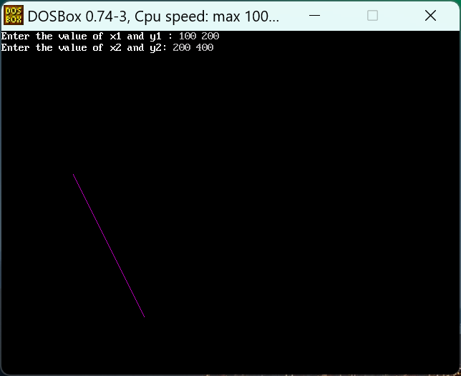

**PRACTICAL NO. – 2**

### **AIM:** Write a program to implement Bresenham’s line algorithm.

### #include <iostream.h>

### #include <graphics.h>

### #include <conio.h>

### 

### void drawline(int x0, int y0, int x1, int y1)

### {

### int dx, dy, p, x, y;

### 

### dx = x1 - x0;

### dy = y1 - y0;

### 

### x = x0;

### y = y0;

### 

### p = 2 * dy - dx;

### 

### while (x < x1)

### {

### if (p >= 0)

### {

### putpixel(x, y, 7);

### y = y + 1;

### p = p + 2 * dy - 2 * dx;

### }

### else

### {

### putpixel(x, y, 7);

### p = p + 2 * dy;

### }

### x = x + 1;

### }

### }

### 

### int main()

### {

### int gdriver = DETECT, gmode, error, x0, y0, x1, y1;

### initgraph(&gdriver, &gmode, "c:\\turboc3\\bgi");

### 

### cout << "Enter co-ordinates of first point: ";

### cin >> x0 >> y0;

### 

### cout << "Enter co-ordinates of second point: ";

### cin >> x1 >> y1;

### drawline(x0, y0, x1, y1);

### 

### getch();

### closegraph();

### return 0;

### }

### 

### 

**Output:**

### 

### 

**PRACTICAL NO. – 3**

### **AIM:** Write a program to implement Bresenham’s circle algorithm.

### #include <iostream.h>

### #include <dos.h>

### #include <conio.h>

### #include <graphics.h>

### 

### void drawCircle(int xc, int yc, int x, int y)

### {

### putpixel(xc + x, yc + y, WHITE);

### putpixel(xc - x, yc + y, WHITE);

### putpixel(xc + x, yc - y, WHITE);

### putpixel(xc - x, yc - y, WHITE);

### putpixel(xc + y, yc + x, WHITE);

### putpixel(xc - y, yc + x, WHITE);

### putpixel(xc + y, yc - x, WHITE);

### putpixel(xc - y, yc - x, WHITE);

### }

### 

### // Function for circle-generation using Bresenham's algorithm

### void circleBres(int xc, int yc, int r)

### {

### int x = 0, y = r;

### int d = 3 - 2 * r;

### while (y >= x)

### {

### drawCircle(xc, yc, x, y);

### x++;

### if (d > 0)

### {

### y--;

### d = d + 4 * (x - y) + 10;

### }

### else

### d = d + 4 * x + 6;

### drawCircle(xc, yc, x, y);

### delay(50);

### }

### }

### 

### int main()

### {

### int xc = 50, yc = 50, r = 30;

### int gd = DETECT, gm;

### initgraph(&gd, &gm, "c:\\turboc3\\bgi");

### circleBres(xc, yc, r);

### getch();

### closegraph();

### return 0;

### }

### 

**Output:**

### **PRACTICAL NO. – 4**

### **AIM:** Write a program to move and object using 2-D transformation.

#include <bits/stdc++.h>

#include <graphics.h>

using namespace std;

// function to translate rectangle

void translateRectangle(int P[][2], int T[])

{

int gd = DETECT, gm, errorcode;

initgraph(&gd, &gm, "c:\\turboc3\\bgi");

setcolor(2);

// rectangle (Xmin, Ymin, Xmax, Ymax) original rectangle

rectangle(P[0][0], P[0][1], P[1][0], P[1][1]);

// calculating translated coordinates

P[0][0] = P[0][0] + T[0];

P[0][1] = P[0][1] + T[1];

P[1][0] = P[1][0] + T[0];

P[1][1] = P[1][1] + T[1];

// translated rectangle (Xmin, Ymin, Xmax, Ymax)

rectangle(P[0][0], P[0][1], P[1][0], P[1][1]);

}

int main()

{

int P[2][2] = {5, 8, 12, 18};

int T[] = {2, 1}; // translation factor

translateRectangle(P, T);

return 0;

}

**Output:**

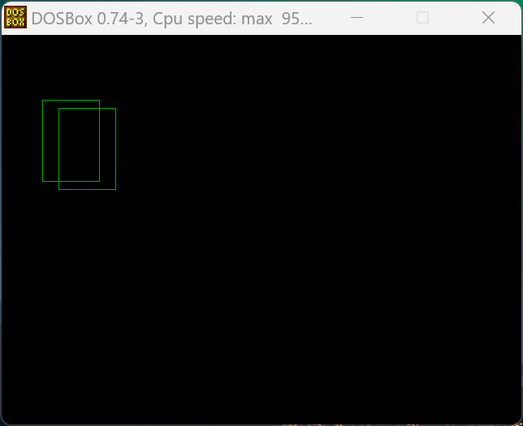

### 

### **PRACTICAL NO. – 5**

### **AIM:** Write a program to implement the midpoint circle drawing algorithm.

#include <iostream.h>

#include <conio.h>

#include <graphics.h>

void drawcircle(int x0, int y0, int radius)

{

int x = radius;

int y = 0;

int err = 0;

while (x >= y)

{

putpixel(x0 + x, y0 + y, 7);

putpixel(x0 + y, y0 + x, 7);

putpixel(x0 - y, y0 + x, 7);

putpixel(x0 - x, y0 + y, 7);

putpixel(x0 - x, y0 - y, 7);

putpixel(x0 - y, y0 - x, 7);

putpixel(x0 + y, y0 - x, 7);

putpixel(x0 + x, y0 - y, 7);

if (err <= 0)

{

y += 1;

err += 2 * y + 1;

}

if (err > 0)

{

x -= 1;

err -= 2 * x + 1;

}

}

}

int main()

{

int gdriver = DETECT, gmode, error, x, y, r;

initgraph(&gdriver, &gmode, "c:\\turboc3\\bgi");

cout << "Enter radius of circle: ";

cin >> r;

cout << "Enter co-ordinates of center(x and y): ";

cin >> x >> y;

drawcircle(x, y, r);

getch();

closegraph();

return 0;

}

**Output:**

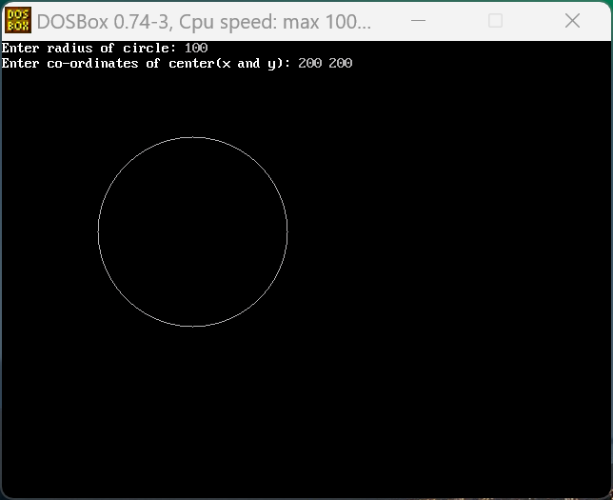

### 

### 

### **PRACTICAL NO. – 6**

### **AIM:** Write a program to implement a line clipping algorithm.

#include <iostream.h>

#include <stdlib.h>

#include <conio.h>

#include <math.h>

#include <graphics.h>

#include <dos.h>

typedef struct coordinate

{

int x, y;

char code[4];

} PT;

void drawwindow();

void drawline(PT p1, PT p2);

PT setcode(PT p);

int visibility(PT p1, PT p2);

PT resetendpt(PT p1, PT p2);

void main()

{

int gd = DETECT, v, gm;

PT p1, p2, p3, p4, ptemp;

cout << "\nEnter x1 and y1\n";

cin >> p1.x >> p1.y;

cout << "\nEnter x2 and y2\n";

cin >> p2.x >> p2.y;

initgraph(&gd, &gm, "c:\\turboc3\\bgi");

drawwindow();

delay(500);

drawline(p1, p2);

delay(500);

cleardevice();

delay(500);

p1 = setcode(p1);

p2 = setcode(p2);

v = visibility(p1, p2);

delay(500);

switch (v)

{

case 0:

drawwindow();

delay(500);

drawline(p1, p2);

break;

case 1:

drawwindow();

delay(500);

break;

case 2:

p3 = resetendpt(p1, p2);

p4 = resetendpt(p2, p1);

drawwindow();

delay(500);

drawline(p3, p4);

break;

}

delay(500);

getch();

closegraph();

}

void drawwindow()

{

line(150, 100, 450, 100);

line(450, 100, 450, 350);

line(450, 350, 150, 350);

line(150, 350, 150, 100);

}

void drawline(PT p1, PT p2)

{

line(p1.x, p1.y, p2.x, p2.y);

}

PT setcode(PT p) // for setting the 4 bit code

{

PT ptemp;

if (p.y < 100)

ptemp.code[0] = '1'; // Top

else

ptemp.code[0] = '0';

if (p.y > 350)

ptemp.code[1] = '1'; // Bottom

else

ptemp.code[1] = '0';

if (p.x > 450)

ptemp.code[2] = '1'; // Right

else

ptemp.code[2] = '0';

if (p.x < 150)

ptemp.code[3] = '1'; // Left

else

ptemp.code[3] = '0';

ptemp.x = p.x;

ptemp.y = p.y;

return (ptemp);

}

int visibility(PT p1, PT p2)

{

int i, flag = 0;

for (i = 0; i < 4; i++)

{

if ((p1.code[i] != '0') || (p2.code[i] != '0'))

flag = 1;

}

if (flag == 0)

return (0);

for (i = 0; i < 4; i++)

{

if ((p1.code[i] == p2.code[i]) && (p1.code[i] == '1'))

flag = '0';

}

if (flag == 0)

return (1);

return (2);

}

PT resetendpt(PT p1, PT p2)

{

PT temp;

int x, y, i;

float m, k;

if (p1.code[3] == '1')

x = 150;

if (p1.code[2] == '1')

x = 450;

if ((p1.code[3] == '1') || (p1.code[2] == '1'))

{

m = (float)(p2.y - p1.y) / (p2.x - p1.x);

k = (p1.y + (m * (x - p1.x)));

temp.y = k;

temp.x = x;

for (i = 0; i < 4; i++)

temp.code[i] = p1.code[i];

if (temp.y <= 350 && temp.y >= 100)

return (temp);

}

if (p1.code[0] == '1')

y = 100;

if (p1.code[1] == '1')

y = 350;

if ((p1.code[0] == '1') || (p1.code[1] == '1'))

{

m = (float)(p2.y - p1.y) / (p2.x - p1.x);

k = (float)p1.x + (float)(y - p1.y) / m;

temp.x = k;

temp.y = y;

for (i = 0; i < 4; i++)

temp.code[i] = p1.code[i];

return (temp);

}

else

return (p1);

}

**Output:**

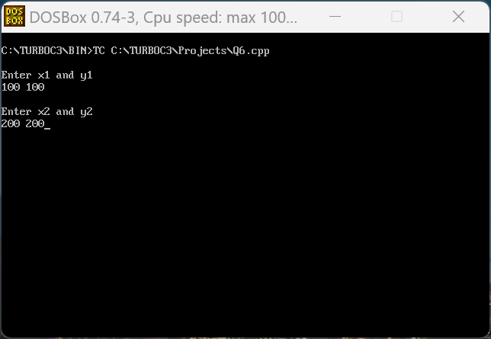

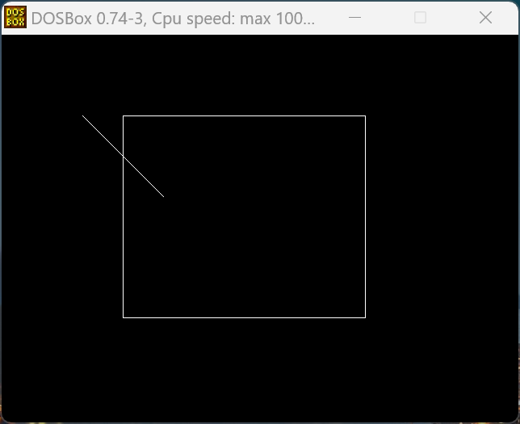

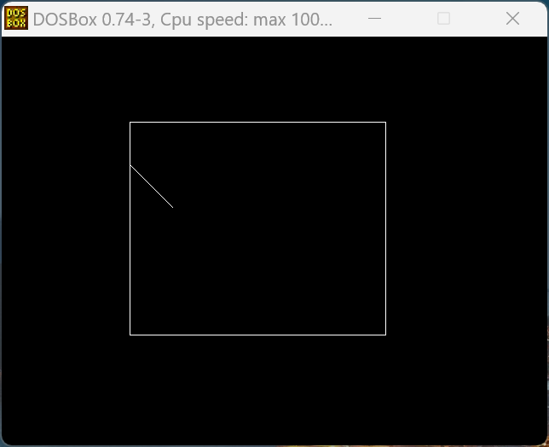

### **PRACTICAL NO. – 7**

### **AIM:** Write a program to implement boundary fill algorithm.

#include <graphics.h>

#include <conio.h>

#include<dos.h>

void boundaryFill4(int x, int y, int fill_color, int boundary_color)

{

if (getpixel(x, y) != boundary_color && getpixel(x, y) != fill_color)

{

putpixel(x, y, fill_color);

delay(10);

boundaryFill4(x + 1, y, fill_color, boundary_color);

boundaryFill4(x-1, y, fill_color, boundary_color);

boundaryFill4(x, y+1, fill_color, boundary_color);

boundaryFill4(x, y - 1, fill_color, boundary_color);

}

}

int main()

{

// gm is Graphics mode which is a computer display mode that generates image using pixels.

// DETECT is a macro defined in "graphics.h" header file

int gd = DETECT, gm;

initgraph(&gd, &gm, "c:\\turboc3\\bgi");

int x = 100, y = 100, radius = 50;

circle(x, y, radius);

boundaryFill4(x, y, 6, 15);

getch();

closegraph();

return 0;

}

**Output:**

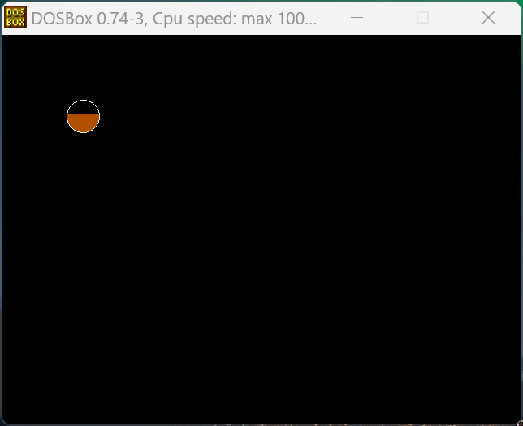

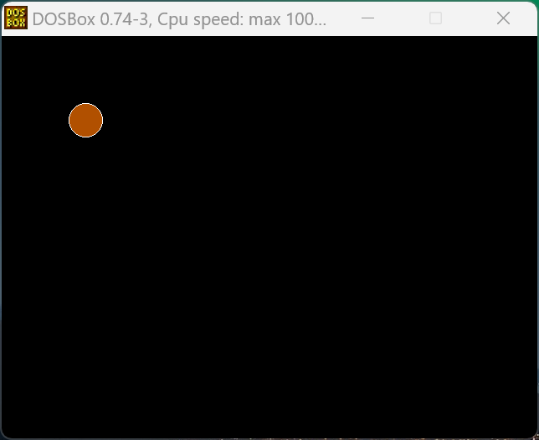

### **PRACTICAL NO. – 8**

### **AIM:** Write a program to implement a polygon clipping algorithm.

#include <iostream.h>

#include <conio.h>

#include <graphics.h>

#define round(a) ((int)(a + 0.5))

int k;

float xmin, ymin, xmax, ymax, arr[20], m;

void clipl(float x1, float y1, float x2, float y2)

{

if (x2 - x1)

m = (y2 - y1) / (x2 - x1);

else

m = 100000;

if (x1 >= xmin && x2 >= xmin)

{

arr[k] = x2;

arr[k + 1] = y2;

k += 2;

}

if (x1 < xmin && x2 >= xmin)

{

arr[k] = xmin;

arr[k + 1] = y1 + m * (xmin - x1);

arr[k + 2] = x2;

arr[k + 3] = y2;

k += 4;

}

if (x1 >= xmin && x2 < xmin)

{

arr[k] = xmin;

arr[k + 1] = y1 + m * (xmin - x1);

k += 2;

}

}

void clipt(float x1, float y1, float x2, float y2)

{

if (y2 - y1)

m = (x2 - x1) / (y2 - y1);

else

m = 100000;

if (y1 <= ymax && y2 <= ymax)

{

arr[k] = x2;

arr[k + 1] = y2;

k += 2;

}

if (y1 > ymax && y2 <= ymax)

{

arr[k] = x1 + m * (ymax - y1);

arr[k + 1] = ymax;

arr[k + 2] = x2;

arr[k + 3] = y2;

k += 4;

}

if (y1 <= ymax && y2 > ymax)

{

arr[k] = x1 + m * (ymax - y1);

arr[k + 1] = ymax;

k += 2;

}

}

void clipr(float x1, float y1, float x2, float y2)

{

if (x2 - x1)

m = (y2 - y1) / (x2 - x1);

else

m = 100000;

if (x1 <= xmax && x2 <= xmax)

{

arr[k] = x2;

arr[k + 1] = y2;

k += 2;

}

if (x1 > xmax && x2 <= xmax)

{

arr[k] = xmax;

arr[k + 1] = y1 + m * (xmax - x1);

arr[k + 2] = x2;

arr[k + 3] = y2;

k += 4;

}

if (x1 <= xmax && x2 > xmax)

{

arr[k] = xmax;

arr[k + 1] = y1 + m * (xmax - x1);

k += 2;

}

}

void clipb(float x1, float y1, float x2, float y2)

{

if (y2 - y1)

m = (x2 - x1) / (y2 - y1);

else

m = 100000;

if (y1 >= ymin && y2 >= ymin)

{

arr[k] = x2;

arr[k + 1] = y2;

k += 2;

}

if (y1 < ymin && y2 >= ymin)

{

arr[k] = x1 + m * (ymin - y1);

arr[k + 1] = ymin;

arr[k + 2] = x2;

arr[k + 3] = y2;

k += 4;

}

if (y1 >= ymin && y2 < ymin)

{

arr[k] = x1 + m * (ymin - y1);

arr[k + 1] = ymin;

k += 2;

}

}

void main()

{

int gd = DETECT, gm, n, poly[20];

float xi, yi, xf, yf, polyy[20];

clrscr();

cout << "Coordinates of rectangular clip window :\nxmin,ymin :";

cin >> xmin >> ymin;

cout << "xmax,ymax :";

cin >> xmax >> ymax;

cout << "\n\nPolygon to be clipped :\nNumber of sides :";

cin >> n;

cout << "Enter the coordinates :";

for (int i = 0; i < 2 * n; i++)

cin >> polyy[i];

polyy[i] = polyy[0];

polyy[i + 1] = polyy[1];

for (i = 0; i < 2 * n + 2; i++)

poly[i] = round(polyy[i]);

initgraph(&gd, &gm, "c:\\turboc3\\bgi");

setcolor(RED);

rectangle(xmin, ymax, xmax, ymin);

cout << "\t\tUNCLIPPED POLYGON";

setcolor(WHITE);

fillpoly(n, poly);

getch();

cleardevice();

k = 0;

for (i = 0; i < 2 * n; i += 2)

clipl(polyy[i], polyy[i + 1], polyy[i + 2], polyy[i + 3]);

n = k / 2;

for (i = 0; i < k; i++)

polyy[i] = arr[i];

polyy[i] = polyy[0];

polyy[i + 1] = polyy[1];

k = 0;

for (i = 0; i < 2 * n; i += 2)

clipt(polyy[i], polyy[i + 1], polyy[i + 2], polyy[i + 3]);

n = k / 2;

for (i = 0; i < k; i++)

polyy[i] = arr[i];

polyy[i] = polyy[0];

polyy[i + 1] = polyy[1];

k = 0;

for (i = 0; i < 2 * n; i += 2)

clipr(polyy[i], polyy[i + 1], polyy[i + 2], polyy[i + 3]);

n = k / 2;

for (i = 0; i < k; i++)

polyy[i] = arr[i];

polyy[i] = polyy[0];

polyy[i + 1] = polyy[1];

k = 0;

for (i = 0; i < 2 * n; i += 2)

clipb(polyy[i], polyy[i + 1], polyy[i + 2], polyy[i + 3]);

for (i = 0; i < k; i++)

poly[i] = round(arr[i]);

if (k)

fillpoly(k / 2, poly);

setcolor(RED);

rectangle(xmin, ymax, xmax, ymin);

cout << "\tCLIPPED POLYGON";

getch();

closegraph();

}

**Output:**

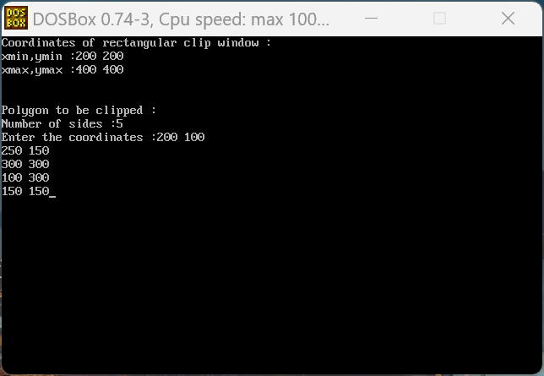

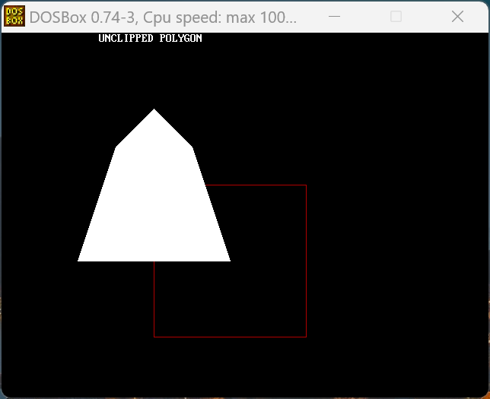

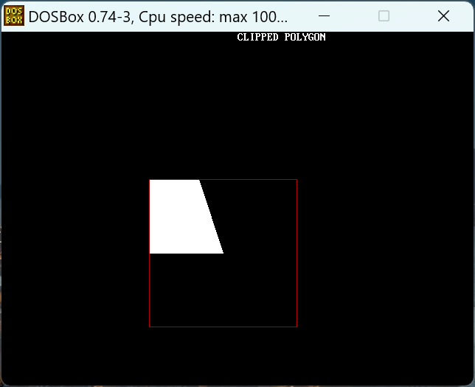

### **PRACTICAL NO. – 9**

### **AIM:** Program To implement line clipping using Cohen-Sutherland line clipping algo.

#include <graphics.h>

#include <conio.h>

#include <stdio.h>

#include <dos.h>

#include <math.h>

void main()

{

int rcode_begin[4] = {0, 0, 0, 0}, rcode_end[4] = {0, 0, 0, 0}, region_code[4];

int W_xmax, W_ymax, W_xmin, W_ymin, flag = 0;

float slope;

int x, y, x1, y1, i, xc, yc;

int gr = DETECT, gm;

initgraph(&gr, &gm, "c:\\turboc3\\bgi");

printf("\n Now, enter XMin, YMin =");

scanf("%d %d", &W_xmin, &W_ymin);

printf("\n First enter XMax, YMax =");

scanf("%d %d", &W_xmax, &W_ymax);

printf("\n Please enter intial point x and y= ");

scanf("%d %d", &x, &y);

printf("\n Now, enter final point x1 and y1= ");

scanf("%d %d", &x1, &y1);

cleardevice();

rectangle(W_xmin, W_ymin, W_xmax, W_ymax);

line(x, y, x1, y1);

line(0, 0, 600, 0);

line(0, 0, 0, 600);

if (y > W_ymax)

{

rcode_begin[0] = 1;

flag = 1;

}

if (y < W_ymin)

{

rcode_begin[1] = 1;

flag = 1;

}

if (x > W_xmax)

{

rcode_begin[2] = 1;

flag = 1;

}

if (x < W_xmin)

{

rcode_begin[3] = 1;

flag = 1;

}

if (y1 > W_ymax)

{

rcode_end[0] = 1;

flag = 1;

}

if (y1 < W_ymin)

{

rcode_end[1] = 1;

flag = 1;

}

if (x1 > W_xmax)

{

rcode_end[2] = 1;

flag = 1;

}

if (x1 < W_xmin)

{

rcode_end[3] = 1;

flag = 1;

}

if (flag == 0)

{

printf("No need of clipping as it is already in window");

}

flag = 1;

for (i = 0; i < 4; i++)

{

region_code[i] = rcode_begin[i] && rcode_end[i];

if (region_code[i] == 1)

flag = 0;

}

if (flag == 0)

{

printf("\n Line is completely outside the window");

}

else

{

slope = (float)(y1 - y) / (x1 - x);

if (rcode_begin[2] == 0 && rcode_begin[3] == 1) // left

{

y = y + (float)(W_xmin - x) * slope;

x = W_xmin;

}

if (rcode_begin[2] == 1 && rcode_begin[3] == 0) // right

{

y = y + (float)(W_xmax - x) * slope;

x = W_xmax;

}

if (rcode_begin[0] == 1 && rcode_begin[1] == 0) // top

{

x = x + (float)(W_ymax - y) / slope;

y = W_ymax;

}

if (rcode_begin[0] == 0 && rcode_begin[1] == 1)

{

x = x + (float)(W_ymin - y) / slope;

y = W_ymin;

}

if (rcode_end[2] == 0 && rcode_end[3] == 1)

{

y1 = y1 + (float)(W_xmin - x1) * slope;

x1 = W_xmin;

}

if (rcode_end[2] == 1 && rcode_end[3] == 0)

{

y1 = y1 + (float)(W_xmax - x1) * slope;

x1 = W_xmax;

}

if (rcode_end[0] == 1 && rcode_end[1] == 0)

{

x1 = x1 + (float)(W_ymax - y1) / slope;

y1 = W_ymax;

}

if (rcode_end[0] == 0 && rcode_end[1] == 1)

{

x1 = x1 + (float)(W_ymin - y1) / slope;

y1 = W_ymin;

}

}

delay(1000);

clearviewport();

rectangle(W_xmin, W_ymin, W_xmax, W_ymax);

line(0, 0, 600, 0);

line(0, 0, 0, 600);

setcolor(RED);

line(x, y, x1, y1);

getch();

closegraph();

}

**Output:**

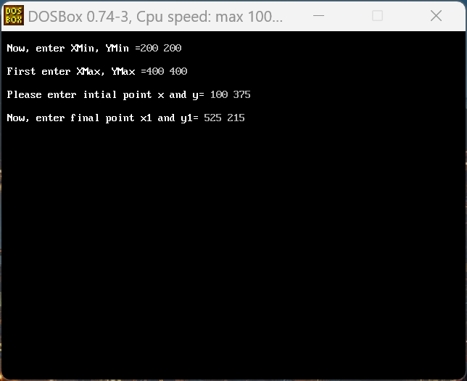

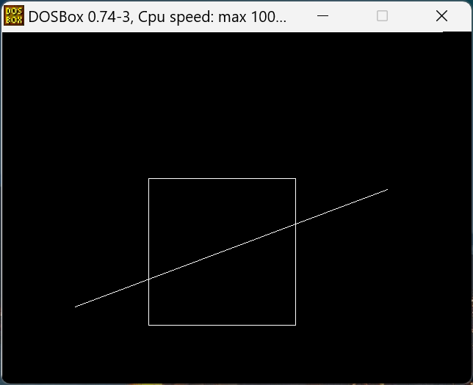

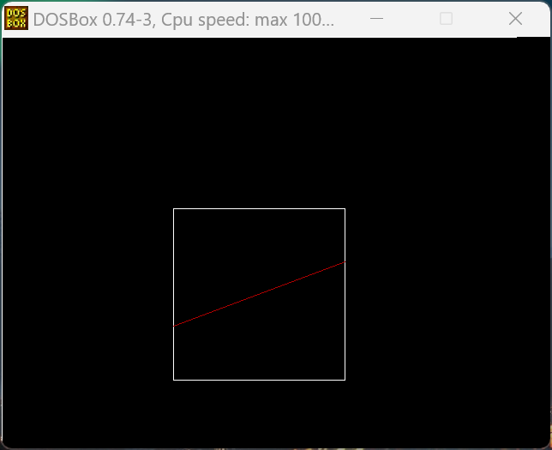

### **PRACTICAL NO. – 10**

### **AIM:** Program To Scale any object.

#include <stdio.h>

#include <conio.h>

#include <graphics.h>

#include <math.h>

int x1, y1, x2, y2, x3, y3, mx, my;

void main()

{

int gd = DETECT, gm;

int x, y, a1, a2, a3, b1, b2, b3;

int mx, my;

int c;

initgraph(&gd, &gm, "C:\\TURBOC3\\BGI");

printf("Enter the 1st point for the triangle:");

scanf("%d%d", &x1, &y1);

printf("Enter the 2nd point for the triangle:");

scanf("%d%d", &x2, &y2);

printf("Enter the 3rd point for the triangle:");

scanf("%d%d", &x3, &y3);

line(x1, y1, x2, y2);

line(x2, y2, x3, y3);

line(x3, y3, x1, y1);

printf("Enter the scalling coordinates");

scanf("%d%d", &x, &y);

mx = (x1 + x2 + x3) / 3;

my = (y1 + y2 + y3) / 3;

a1 = mx + (x1 - mx) * x;

b1 = my + (y1 - my) * y;

a2 = mx + (x2 - mx) * x;

b2 = my + (y2 - my) * y;

a3 = mx + (x3 - mx) * x;

b3 = my + (y3 - my) * y;

line(a1, b1, a2, b2);

line(a2, b2, a3, b3);

line(a3, b3, a1, b1);

getch();

}

**Output:**

